UNITED STATES
SECURITIES AND EXCHANGE COMMISSION
Washington, D.C. 20549

SCHEDULE 14A INFORMATION
Proxy Statement Pursuant to Section 14(a) of the
Securities Exchange Act of 1934
(Amendment No. )

Filed by the Registrant ☒
Filed by a Party other than the Registrant ☐
Check the appropriate box:

☐ | Preliminary Proxy Statement

☐ | Confidential, for Use of the Commission Only (as permitted by Rule 14a-6(e)(2))

☐ | Definitive Proxy Statement

☒ | Definitive Additional Materials

☐ | Soliciting Material Pursuant to §240.14a-12
TANGO THERAPEUTICS, INC.
(Name of registrant as specified in its charter)
(Name of Person(s) Filing Proxy Statement, if other than the Registrant)
Payment of Filing Fee (Check all boxes that apply):

☒ | No fee required.

☐ | Fee paid previously with preliminary materials.

☐ | Fee computed on table in exhibit required by Item 25(b) per Exchange Act Rules 14a-6(i)(1) and 0-11.


Your Vote Counts! TANGO THERAPEUTICS, INC. 2023 Annual Meeting Vote by June 5, 2023 11:59 PM ET TANGO THERAPEUTICS, INC. 201 BROOKLINE AVENUE, SUITE 901 BOSTON, MA 02215 V12700-P92601 You invested in TANGO THERAPEUTICS, INC. and its time to vote! You have the right to vote on proposals being presented at the Annual Meeting. Important Notice Regarding the Availability of Proxy Materials for the Shareholder Meeting to Be Held on June 6, 2023. Get informed before you vote View the Notice and Proxy Statement and Annual Report online at www.ProxyVote.com OR you can receive a free paper or email copy of the material(s) by requesting them prior to May 23, 2023. If you would like to request a copy of the material(s) for this and/or future shareholder meetings, you may (1) visit www.ProxyVote.com, (2) call 1-800-579-1639 or (3) send an email to sendmaterial@proxyvote.com. If sending an email, please include your control number (indicated below) in the subject line. Unless requested, you will not otherwise receive a paper or email copy. For complete information and to vote, visit www.ProxyVote.com Control # Smartphone users Vote Virtually at the Meeting* Point your camera here and June 6, 2023 10:00 AM EDT vote without entering a control number Virtually at: www.virtualshareholdermeeting.com/TNGX2023 *Please check the meeting materials for any special requirements for meeting attendance. V1.1 Vote at www.ProxyVote.com THIS IS NOT A VOTABLE BALLOT This is an overview of the proposals being presented at the upcoming shareholder meeting. Please follow the instructions on the reverse side to vote on these important matters. Voting Items Board Recommends 1. Election of Class II Directors Nominees: 01) Malte Peters, M.D. For 02) Mace Rothenberg, M.D. 2. To ratify the selection of PricewaterhouseCoopers LLP as our independent registered public accounting firm for the For fiscal year ending December 31, 2023. NOTE: The Board of Directors will consider and act upon such other business as may properly come before the meeting or any adjournment thereof. Prefer to receive an email instead? While voting on www.ProxyVote.com, be sure to click Delivery Settings. V12701-P92601 Your Vote Counts! TANGO THERAPEUTICS, INC. 2023 Annual Meeting Vote by June 5, 2023 11:59 PM ET TANGO THERAPEUTICS, INC. 201 BROOKLINE AVENUE, SUITE 901 BOSTON, MA 02215 V12700-P92601 You invested in TANGO THERAPEUTICS, INC. and its time to vote! You have the right to vote on proposals being presented at the Annual Meeting. Important Notice Regarding the Availability of Proxy Materials for the Shareholder Meeting to Be Held on June 6, 2023. Get informed before you vote View the Notice and Proxy Statement and Annual Report online at www.ProxyVote.com OR you can receive a free paper or email copy of the material(s) by requesting them prior to May 23, 2023. If you would like to request a copy of the material(s) for this and/or future shareholder meetings, you may (1) visit www.ProxyVote.com, (2) call 1-800-579-1639 or (3) send an email to sendmaterial@proxyvote.com. If sending an email, please include your control number (indicated below) in the subject line. Unless requested, you will not otherwise receive a paper or email copy. For complete information and to vote, visit www.ProxyVote.com Control # Smartphone users Vote Virtually at the Meeting* Point your camera here and June 6, 2023 10:00 AM EDT vote without entering a control number Virtually at: www.virtualshareholdermeeting.com/TNGX2023 *Please check the meeting materials for any special requirements for meeting attendance. V1.1

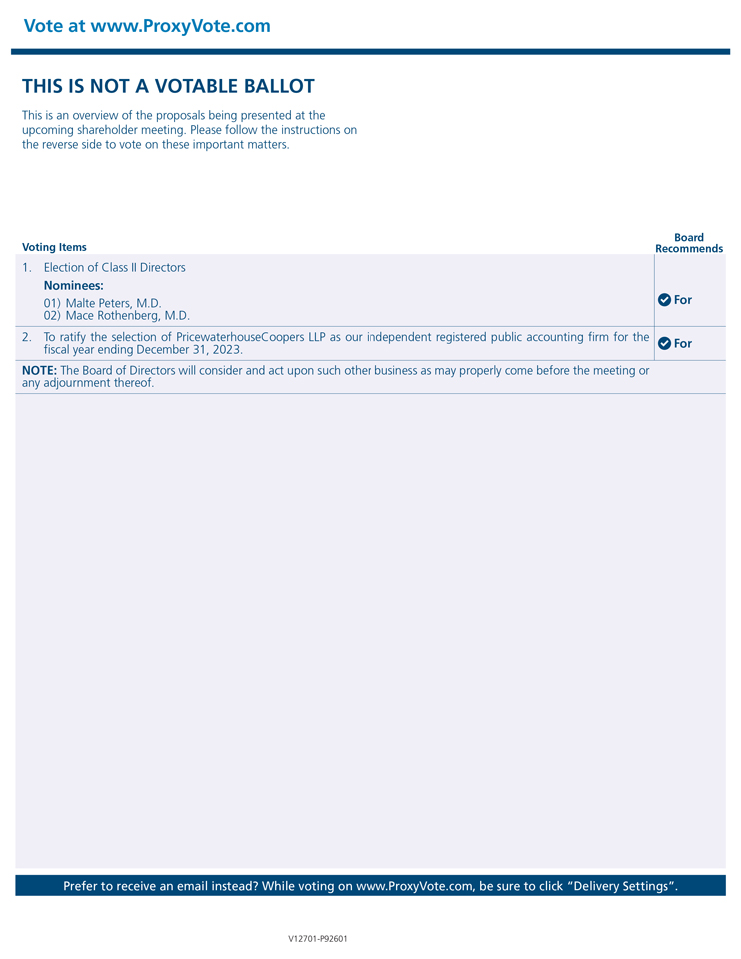
Vote at www.ProxyVote.com THIS IS NOT A VOTABLE BALLOT This is an overview of the proposals being presented at the upcoming shareholder meeting. Please follow the instructions on the reverse side to vote on these important matters. Voting Items Board Recommends 1. Election of Class II Directors Nominees: 01) Malte Peters, M.D. For 02) Mace Rothenberg, M.D. 2. To ratify the selection of PricewaterhouseCoopers LLP as our independent registered public accounting firm for the For fiscal year ending December 31, 2023. NOTE: The Board of Directors will consider and act upon such other business as may properly come before the meeting or any adjournment thereof. Prefer to receive an email instead? While voting on www.ProxyVote.com, be sure to click Delivery Settings. V12701-P92601

