UNITED STATES

SECURITIES AND EXCHANGE COMMISSION
Washington, D.C. 20549

SCHEDULE 14A INFORMATION

Proxy Statement Pursuant to Section 14(a) of the
Securities Exchange Act of 1934

(Amendment No. )

Filed by the Registrant ☒

Filed by a Party other than the Registrant ☐

Check the appropriate box:

- Preliminary Proxy Statement

- Confidential, for Use of the Commission Only (as permitted by Rule 14a-6(e)(2))

- Definitive Proxy Statement

- Definitive Additional Materials

- Soliciting Material Pursuant to §240.14a-12

TANGO THERAPEUTICS, INC.

(Name of registrant as specified in its charter)

(Name of Person(s) Filing Proxy Statement, if other than the Registrant)

Payment of Filing Fee (Check all boxes that apply):

- No fee required.

- Fee paid previously with preliminary materials.

- Fee computed on table in exhibit required by Item 25(b) per Exchange Act Rules 14a-6(i)(1) and 0-11.

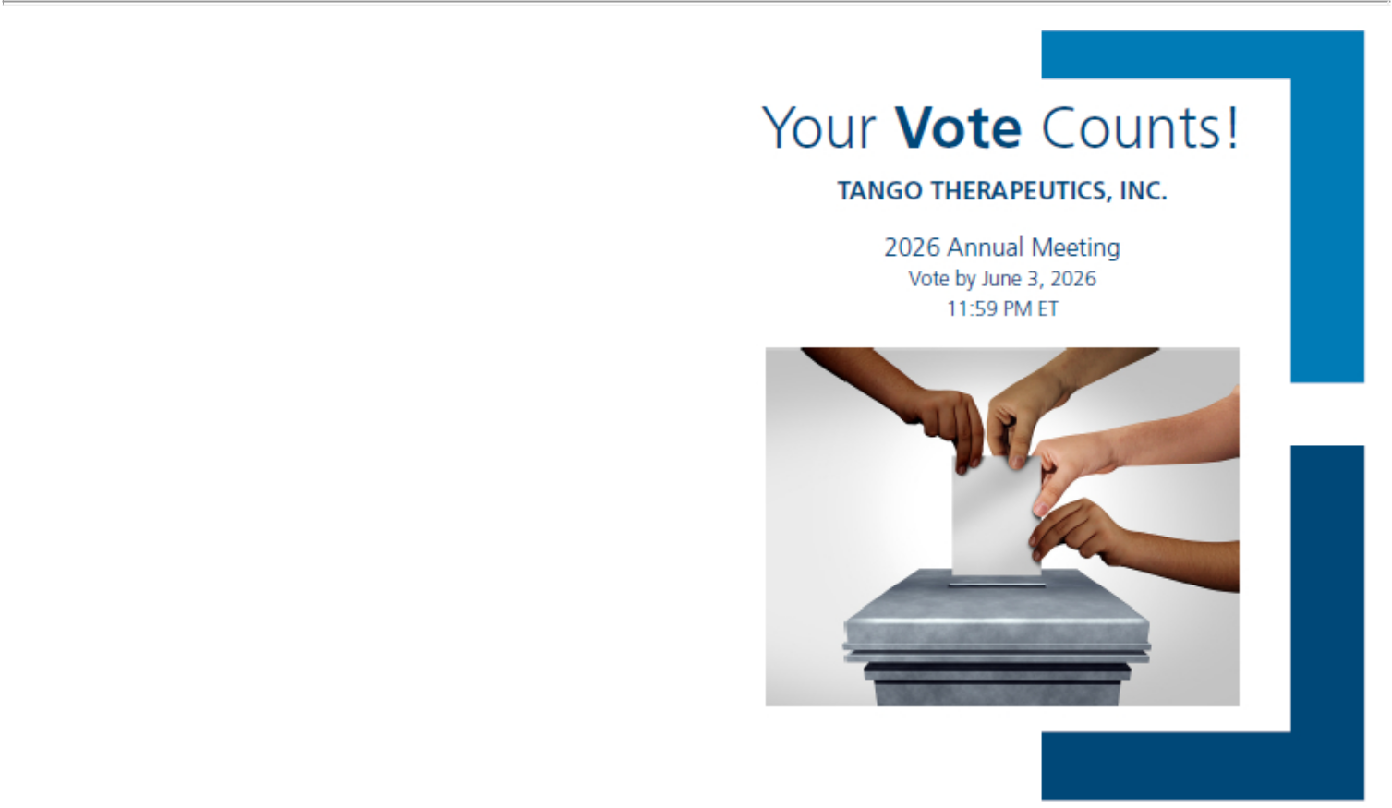

TANGO THERAPEUTICS, INC.
201 BROOKLINE AVENUE, SUITE 901

BOSTON, MA 02215

V90761-P50670

You invested in TANGO THERAPEUTICS, INC. and it’s time to vote!

You have the right to vote on proposals being presented at the Annual Meeting. Important Notice Regarding the Availability of Proxy Materials for the Shareholder Meeting to Be Held on June 4, 2026.

Get informed before you vote

View the Notice and Proxy Statement and Annual Report online at www.ProxyVote.com OR you can receive a free paper or email copy of the material(s) by requesting them prior to May 21, 2026. If you would like to request a copy of the material(s) for this and/or future shareholder meetings, you may (1) visit www.ProxyVote.com, (2) call 1-800-579-1639 or (3) send an email to sendmaterial@proxyvote.com. If sending an email, please include your control number (indicated below) in the subject line. Unless requested, you will not otherwise receive a paper or email copy.
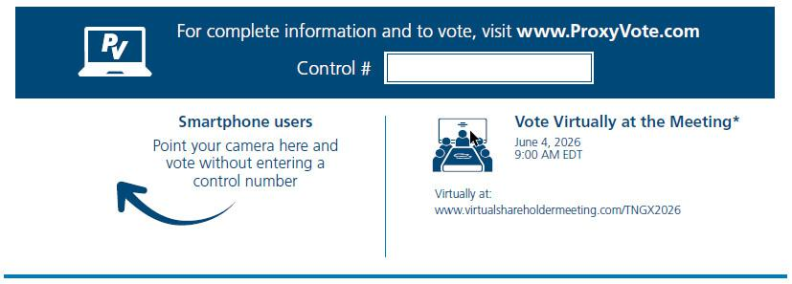

*Please check the meeting materials for any special requirements for meeting attendance.

Vote at www.ProxyVote.com

THIS IS NOT A VOTABLE BALLOT

This is an overview of the proposals being presented at the

upcoming shareholder meeting. Please follow the instructions

on the reverse side to vote on these important matters.

Voting Items
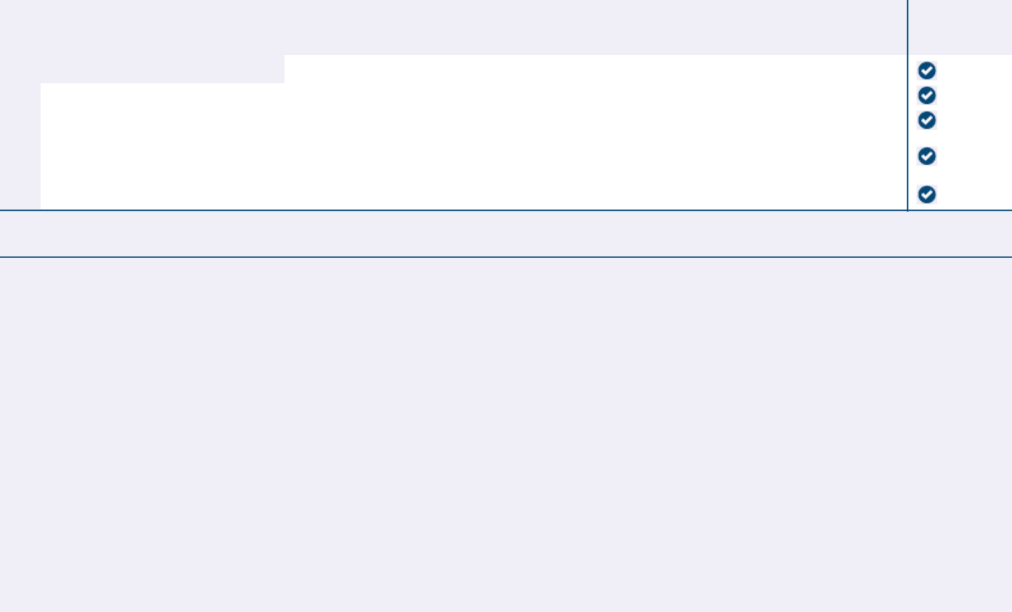

Board

Recommends

- 1. Election of Class II Directors

Company Nominees:

1a. |  |  | For
1a. | Malte Peters, M.D. |  | For
1b. | Kanishka Pothula |  | For
1c. | Mace Rothenberg, M.D. |  | For
2. | To ratify the selection of PricewaterhouseCoopers LLP as our independent registered public accounting firm for the |  | For
 | fiscal year ending December 31, 2026. |  | For
3. | To approve, on a non-binding, advisory basis, the compensation of our named executive officers. |  | For

NOTE: The Board of Directors will consider and act upon such other business as may properly come before the meeting or any adjournment or postponement thereof.

Prefer to receive an email instead? While voting on www.ProxyVote.com, be sure to click “Delivery Settings”.

V90762-P50670

